STEPHEN DIXON

‘MIGRATORY PRACTICES’ CONFERENCE PRESENTATION

Manchester Metropolitan University

6 September 2006

BEYOND THE SEAS: a practice-led research project, investigating the ways in which cultural and geographical dislocation influences craft practice and the creation of material culture.

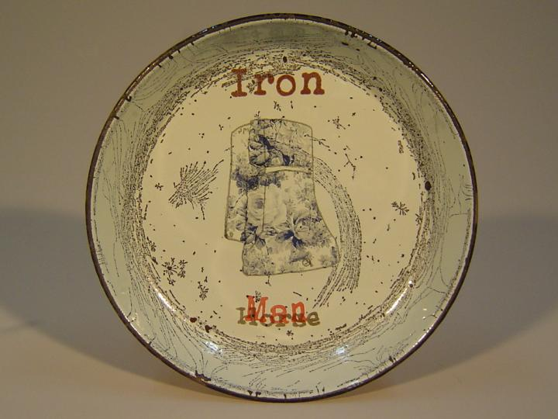
This research question was explored through the medium of my own practice, informed by research on location and in the field. ‘Beyond the Seas’ has been developed within the context of the Here and There (HAT) Asia/UK Project, and was co-funded by the Arts Council UK and the Arts and Humanities Research Council.

An example of my own dislocated practice, ‘Iron man’, a re-contextualised enamelled tin plate (a process christened ‘outback-ware’). Found and re-worked on location in Adelaide, Australia, March 2006.

The project hosts were Jam Factory Craft and Design, Adelaide, South Australia, where I was based from January to April 2006, and the residency coincided with two other visiting ceramic artists in Adelaide, Sergei Isupov from the USA, and Paul Scott from the UK.
Jam Factory also facilitated a research trip into the Pitjantjatjara Aboriginal Tribal lands in the Musgrave Ranges, northern South Australia. A permit is required to enter the homelands, and a guide is recommended. I travelled with Colin Kosh, Director of Ku Arts, on a trip to visit Aboriginal Arts Centres at Ernabella, Tjungu Palya, Freegon and Indulkana.
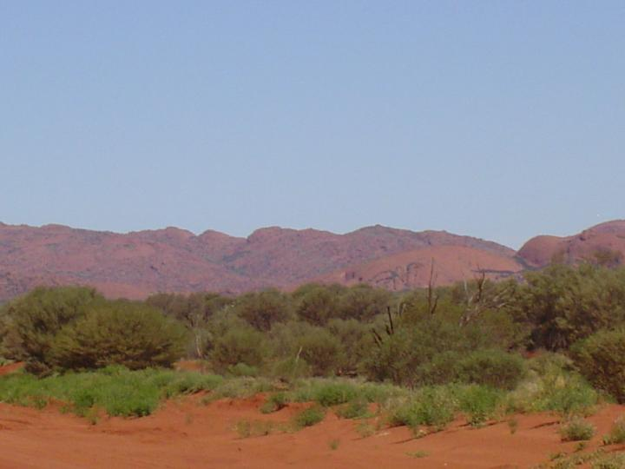
The Musgrove Ranges, viewed towards Indulkana.

It may be illuminating to consider some differing perspectives on the location of my dis-location. Firstly, a map of Australia from a British text-book of 1919, in British Empire Pink…
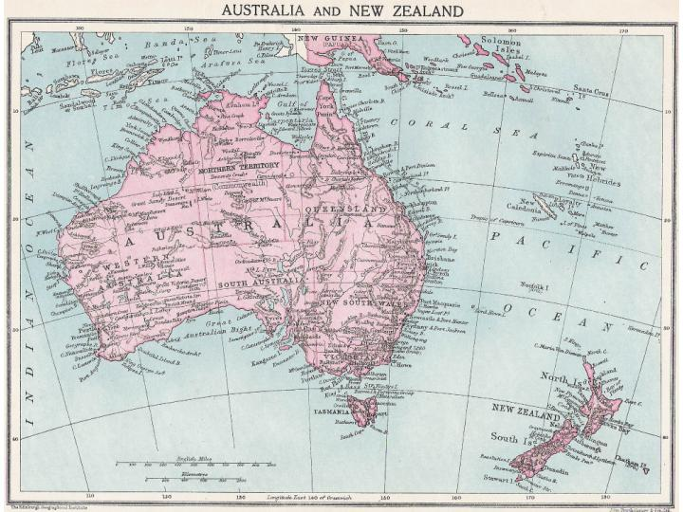

Next is an Anthropological perspective; the Tindale Map of ‘Tribal Boundaries in Aboriginal Australia’ (the work of Australian anthropologist Norman B. Tindale was instrumental in the campaign for Aboriginal land rights).
This map did much to disprove the traditional view of aboriginals as land-less wanderers.
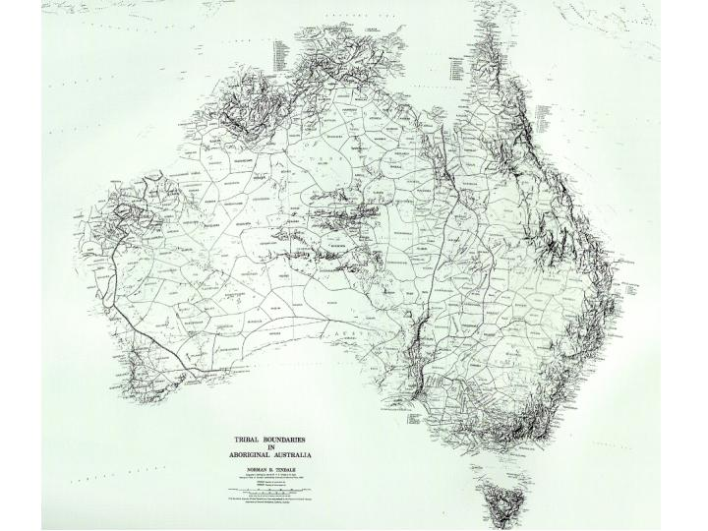

And thirdly a detail of Australia, from an aboriginal ‘dot-painting’, of a curiously westernised map of the world, painted in 2006 by a tribal elder of the ERNABELLA community. The Pitjantjatjara Aboriginal Homelands are the black area in the centre (this was to be the subject of his next painting).

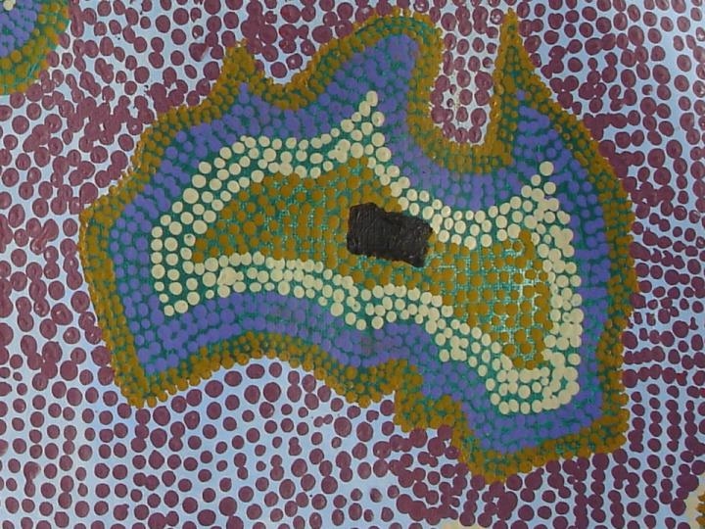

1. RESEARCH QUESTIONS.

My initial research focussed on a number of sub-questions, some of these relating to the settler experience:

- What evidence is provided by the historical artefacts and material culture of the colonists and settlers?
- Do these colonial artefacts differ from artefacts produced in the UK?
- Were new forms of artefact created, and if so why?

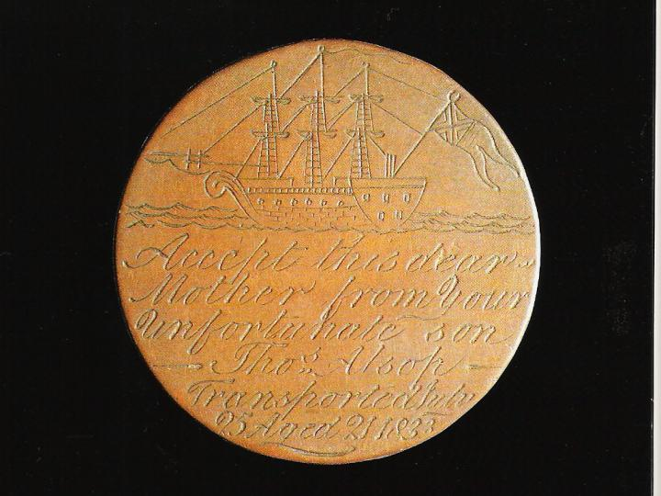
Research in Museums, Libraries and archives in Adelaide, Canberra, Sydney and Melbourne gave some answers to these questions, revealing a number of examples of uniquely Australian artefacts, and a ‘making-do’ vernacular tradition influenced by hardship and scarcity of resources and materials.

Convict love tokens were de-faced and engraved George III
cartwheel pennies. Made by British convicts awaiting transportation to Australia, they were given as keepsakes to the loved ones the convicts were unlikely ever to see again.

Accept this dear mother from your unfortunate son. Thos. Alsop.
Transported July 25th Aged 21, 1833.
On the reverse is the rhyme:
The Rose soon Drupes and Dies,
The Brier fades away,
But my fond heart for you I love,
Shall never go astray.

The booklet ‘Makeshifts’ was produced by the New Settlers League in 1924 (interestingly sponsored by kerosene manufacturer British Imperial Oil).
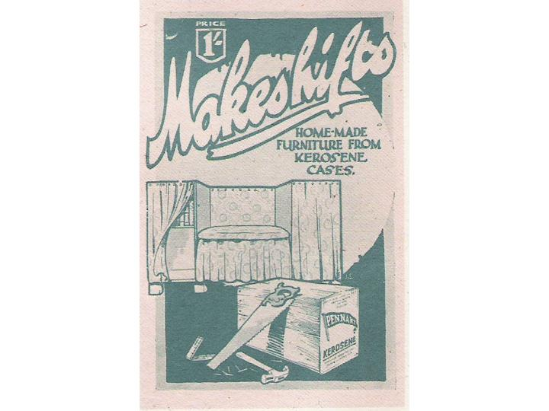
It advocated a ‘making-do’ material culture, using packing cases, kerosene cans and oil drums as raw material. The booklet was so popular in depression-era Australia that an enlarged edition was re-published the following year.

Such makeshift flair and eccentricity is typified in this home-made food safe or Bush Pantry of the 1920’s (now in the Powerhouse Museum, Sydney).
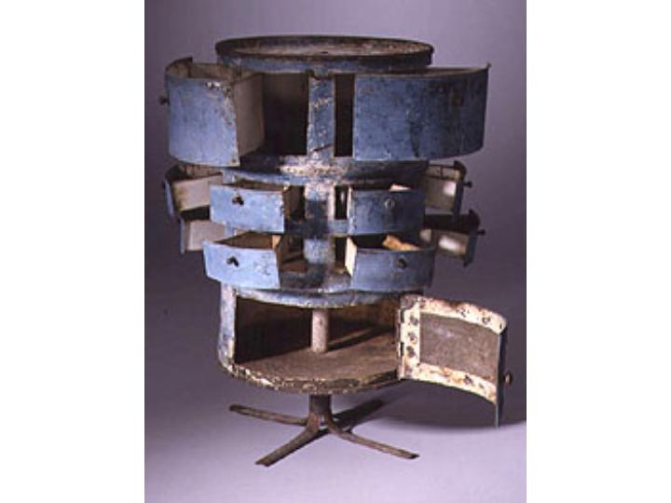

“It appears that the maker was inspired by the ‘Rotary Kitchen Canister’ advertised in Anthony Hordern’s 1923 mail order catalogue, and went to elaborate lengths to create a home-made replica. The skill needed suggests that the maker’s normal farm work may have involved using sheet metal to make rudimentary water tanks and roofing. A fine example of ‘making-do’, involving the salvaging of a commonplace refuse item and transforming it into a useful piece of furniture…” (Powerhouse Museum archive notes)
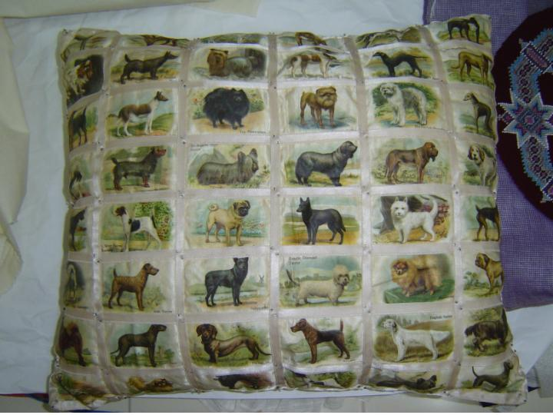

More commonplace domestic skills were used to recycle silk cigarette cards into cushion covers…
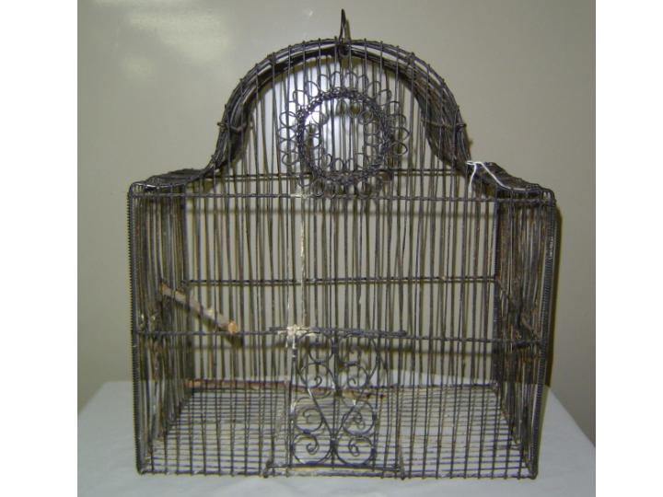

…and to construct birdcages from fencing wire. (Both of these objects are from the Powerhouse Museum Archive.)
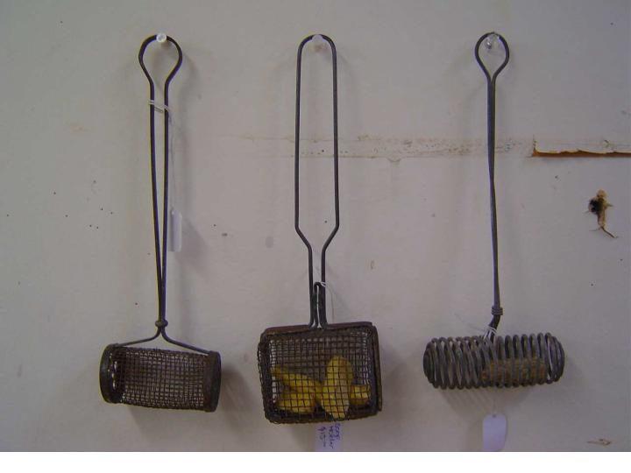
These soap holders were collected on one of my regular trawls of Adelaide antique and ‘op-shops’. Though not home made, they typify the thrifty, ‘making-do’ culture of depression-era Australia in the 1920’s.

Very few western artefacts were of interest to Aboriginals at first contact.
As Cook noted in his journal, “unacquainted…with…the necessary conveniences so much sought after in Europe, they are happy in not knowing the use of them as they seem’d to set no value upon any thing we gave them,
nor would they ever part with anything of their own for any one article we could offer them.”
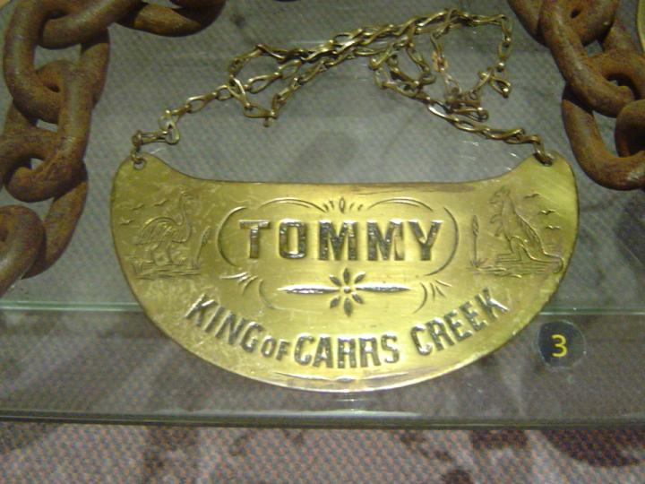
One rare example of an artefact making a cultural crossover is the so called ‘Aboriginal King-Plate’.

Copied from a regimental ‘throat-plate’ or ‘gorget’, the king-plate became an indicator of status within tribal groups. Its adoption aided the imposition of European systems of hierarchy, and subverted traditional indigenous social structures.

A second group of research questions focussed on Indigenous craft and culture:

- How were Aboriginal Craft Traditions dislocated during the colonial period?
- To what extent are tradition and contemporary craft practices compatible?
- Has Globalisation and the communication revolution more recently affected indigenous craft practice?

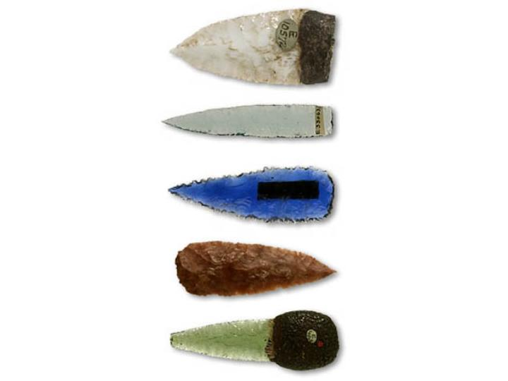
Again, preliminary research in museums and archives revealed examples and provided some answers.

Stone spear points, flaked on two sides, were traditionally produced in the Kimberly Region of the Northern Territories. Known as Kimberly Points, they were both practical and aesthetically prized, and were collected and traded throughout Northern Australia. Glass provided a perfect alternative material, and though rare was known to Aboriginals through trade with Indonesian Trepang fishermen. (Trepang, or sea cucumbers, were used in Chinese medicines, and as an aphrodisiac.) Following European colonisation, discarded bottle glass, along with porcelain from dinnerware, became more readily available, and was recycled by indigenous spear-makers. The construction of the overland telegraph line introduced another source of glass, in the form of telegraph insulators.
One generic type of Indigenous artefact has survived the transition from pre-colonial to post-colonial society, this is the bush toy. Traditional wood and bark discs featured in Aboriginal childs-play, as a game of target practice, to teach spear-throwing skills.
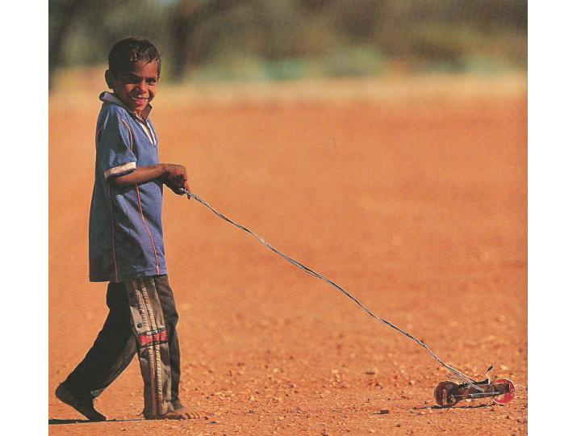
These objects have their contemporary counterpart in the push-along cars, trucks and motorbikes of Arrernte children from Central Australia.

This toy helicopter, by Johnny Young of the Titjikala community, shows the characteristic resourcefulness of the Aboriginal maker, exploiting available scrap and discarded materials to great effect.
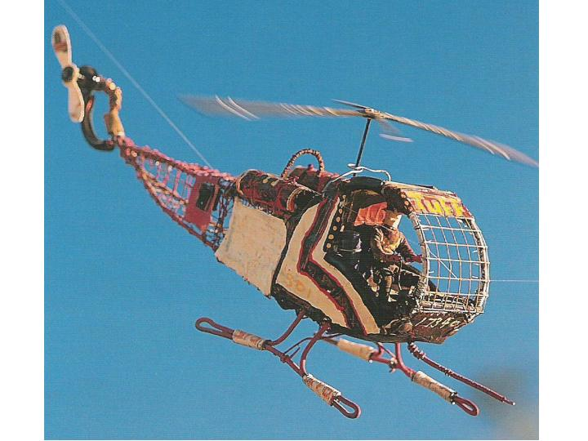

Easily the most iconic of contemporary indigenous art forms is the dot-painting on canvas, and much debate has centred upon the ‘authenticity’ of this tradition. Muecke and Shoemaker have described how this art-form recently evolved:
“For a long time Aboriginal plastic arts were tied to specific places, bodies and ceremonies and were not produced for sale or exhibition. In the 1970s, people were encouraged to produce paintings on bark or canvas, and a new chapter began in the history of Australian art, as an authentic and ancient set of images reasserted itself over the more ephemeral art forms of the settlers.
Far from being fixed, these images were original and modern, yet continuously reaching back to the Dreaming cultures for inspiration.”
Authentic or not, the international commercial success of Australian Indigenous Art is beyond question, and contributes an estimated 50 million US dollars to the Australian economy.

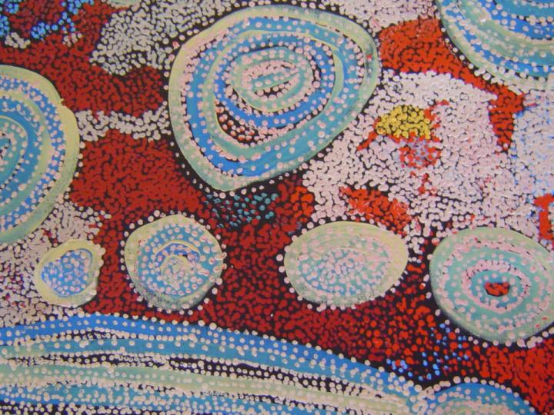
Detail of a painting by the Nyapari artist Wingu, from Tjungu Palya art centre.

The Art Centres provide an invaluable service to the Aboriginal artistic communities: maintaining market networks, technical and social support structures, and promoting the long-term viability of indigenous Australian arts.

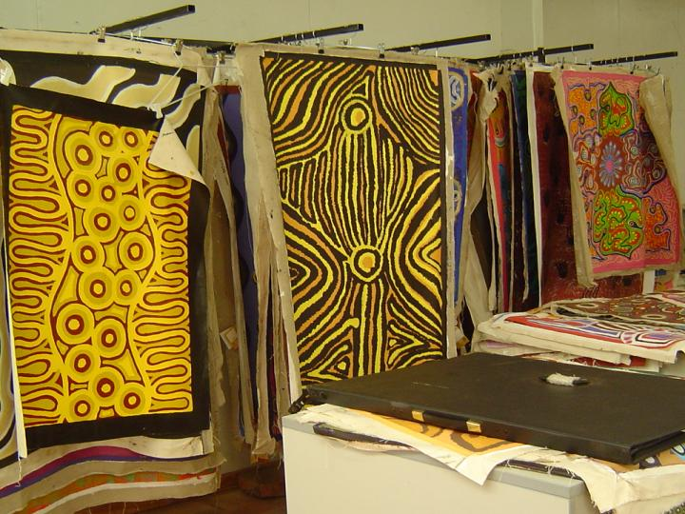
Racked canvasses, produced by the indigenous artists at Freegon Art Centre, awaiting transport to galleries in the coastal cities of Australia.

Much of the ‘acrylic-on-canvas’ painting has maintained a traditionally introspective narrative, informed by individual ‘dreamings’ kinship, and relationships with the land. However, a younger generation of indigenous painters have begun to challenge this viewpoint, exploiting the formal traditions of indigenous painting, whilst engaging with contemporary social and political issues.
Gordon Bennett’s early works questioned settler values and National Identity in the absence of ‘The Australian Other’.

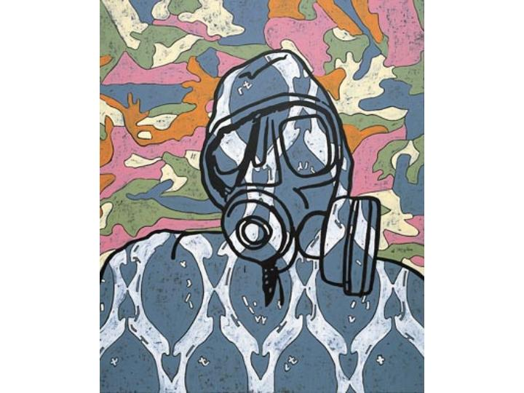
Here he turns a critical eye from historical British colonialism to contemporary American imperialism, in a recent painting “Camouflage # 2’’, of 2003
Contemporary indigenous craft, of the originality and quality of contemporary indigenous fine art is harder to find.
One might speculate that this is a direct result of market forces – canvases fetch the highest prices in the sales room – and also a result of the redundancy of purposeful indigenous artefacts (tools, weapons, vessels) within the contemporary reality of a sedentary lifestyle.
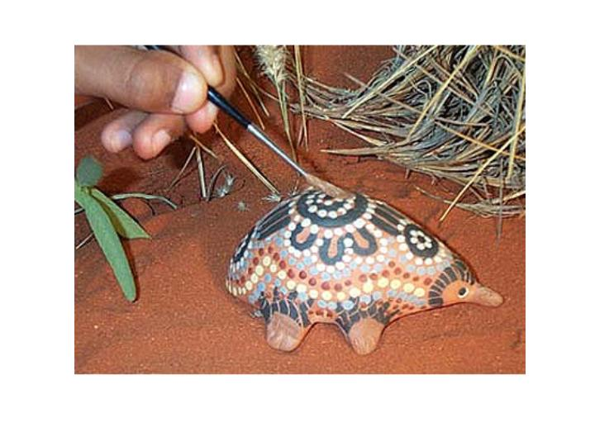
Though much aboriginal craftwork is produced, and marketed globally via the internet, ‘tourist craft’ pre-dominates.
This ceramic echidna is, of course, a work of ‘craft-fiction’, there is no pottery tradition within indigenous Australian crafts.

2. ETHICAL ISSUES

A number of ethical issues were raised, both by the initial preparations for the project, and by the experiences gained during the residency and in the field.
These issues include cultural sensitivities around the imperial/colonial legacy, engagement with Aboriginal Protocols, and reflection on the context of my own ‘political’ craft practise.
Consideration of these issues, some of which were not anticipated, has informed the context and direction of the project.

The pervasive legacy of the British Empire, its traditions, institutions and the monuments to its heroes, can be seen in every major Australian city. Australia’s historical commercial importance to the Empire can be seen in a chart from a school text-book of 1919. Australian wheat, sugar, coal, gold, silver (and of course wool, not shown here) made up 20% of British trade with the empire in 1919.
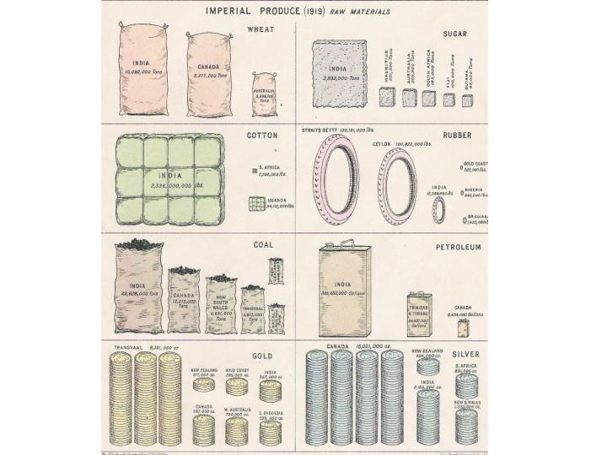
Imperial monuments abound, in all of Australia’s major cities.
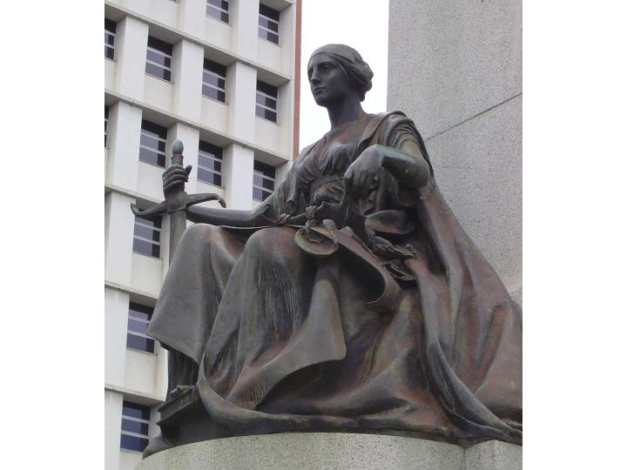
This figure is ‘Justice’ by Bertram Mackennal, A.R.A, part of the King Edward VII memorial, on Adelaide’s North Terrace.

In particular, memories of colonial Australia’s bleak beginnings are preserved in the edifices of crime and punishment The prisons at Hyde Park Barracks and Darlinghurst, both built by convict hard-labour, still survive, the former as a museum of penal history, the latter as home to the National School of Art.
Old Melbourne Goal has now become a monument to the (romanticised) memory of the gold-field robbers and Bushrangers of popular legend.

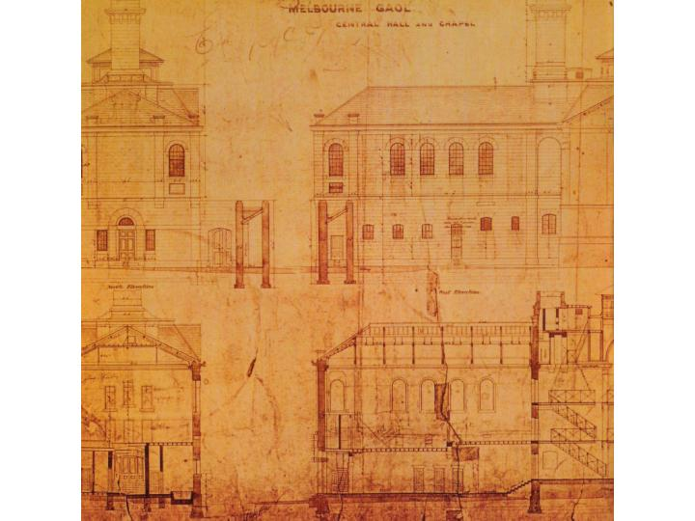

The death-masks of these criminals, cast in plaster after their execution, now decorate the prison cells. None more famous than Ned Kelly himself, executed here on November 11th 1880.

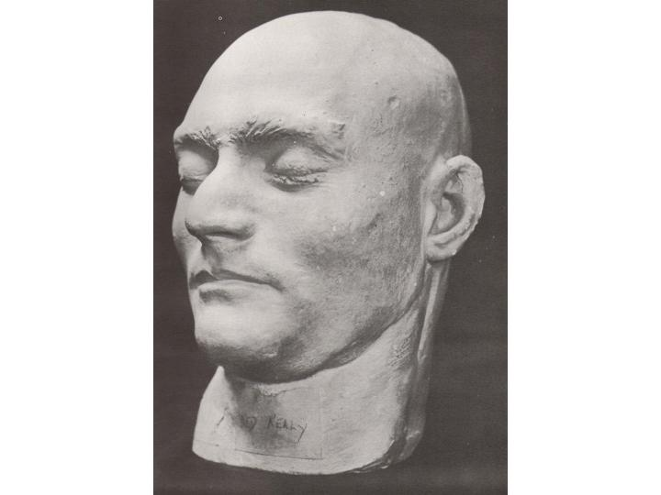
Another example of the brutality of the colonial penal system is the silence hood, designed to prevent recognition and communication between prisoners.
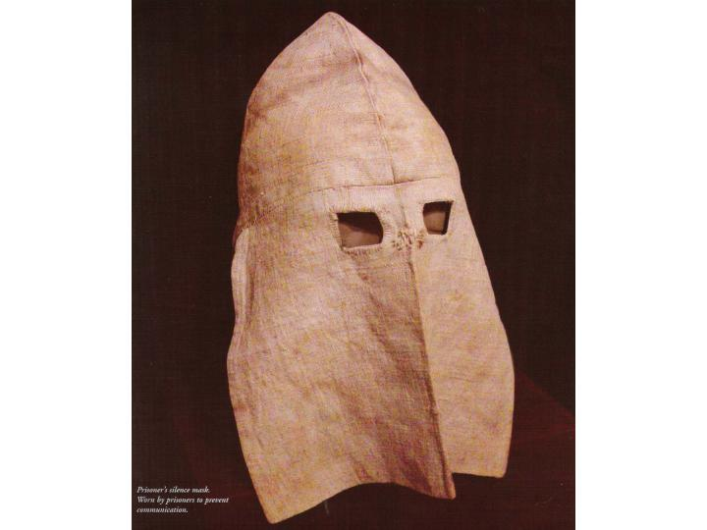

Cultural sensitivity was also a major ethical issue, particularly in the Aboriginal homelands. I had hoped to document the work done at the Indigenous Art Centres while ‘in the field’, but quickly encountered Aboriginal protocols around the taking and ownership of images.
Although I obtained permission to photograph painters at work at Ernabella, both from the Art Centre staff and the artists themselves, the painters’ unease and body language is hard to ignore.
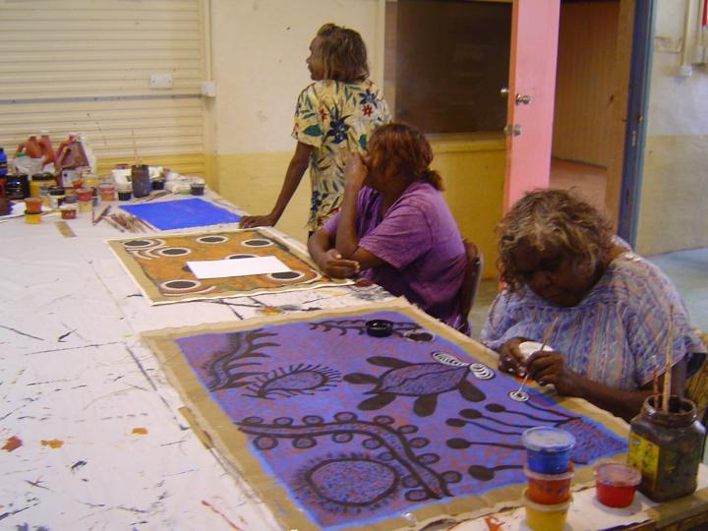
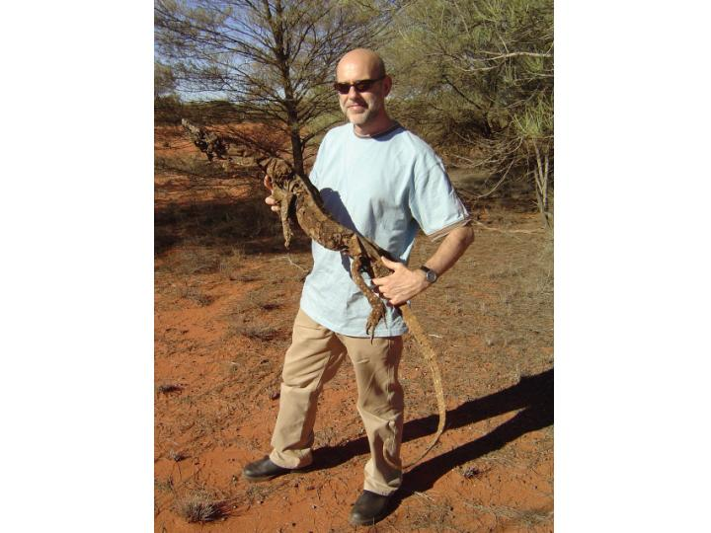
Protocols also prevent the taking of anything from the homelands without specific permission. I found this dessicated skeleton of ‘Nintaka’, a perenti lizard, in the Malilanya cave near Ernabella.

Nintaka travelled around the homelands with us for 3 days. During this time a sub-project emerged, which would incorporate local dreamtime narratives, within a bone-china ceramic object, made from the calcined bones of nintaka
(and when completed this piece would be returned to the homelands).
However, despite local permission to take the skeleton away, we weren’t sure this satisfied the protocols, and so Nintaka was left in the homelands.
However, the ‘bone-china’ idea had taken hold, and as an alternative to lizard bones, the return trip to Adelaide was spent collecting bones from the plentiful road-kills along the edge of the main Highway. (Mostly Kangaroo, but sometimes Emu too – the iconography of Australia’s coat of arms!)
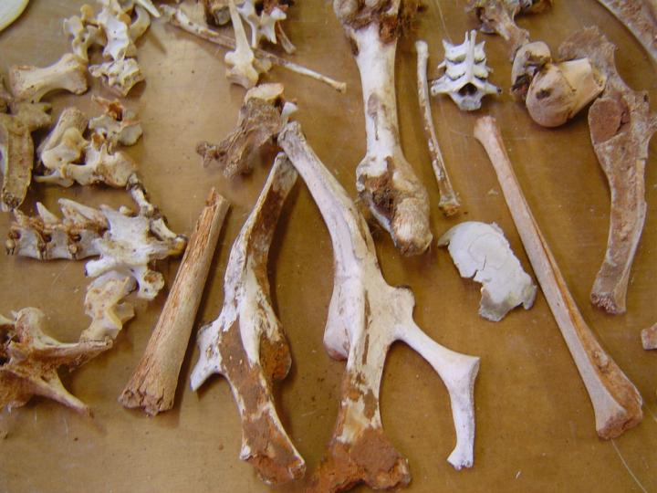
My collection of kangaroo and emu bones were turned into bone ash at the Jam Factory studio (by calcining, or burning in the kiln) and grinding to a fine powder) to post back to Manchester.

3. NEW RESEARCH INTERESTS

Inevitably, the development of practice in residence, and the consideration of ethical issues ‘in the field’, has resulted in a reshaping of my research interests within the project.
I have become interested in the ‘iconisation’ of characters and narratives.
How did a petty criminal, apprenticed as a bush-ranger at the age of 14 become Ned Kelly, folk-hero, national icon and star of stage, screen and meat pie?
Was it a popular identification with the story itself, as an analagy of the poor settler society struggling against the casual brutality of the mother country,
and the racism and political corruption of the authorities?
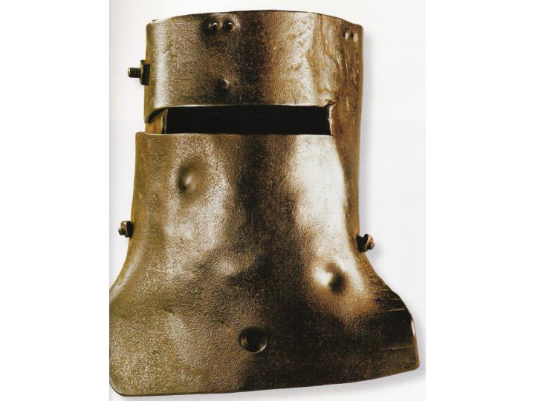

Was it the symbolic power of the image?
Ned’s home-made armour, hammered out from plough mould-boards, has become one of Australia’s great cultural icons. A national treasure, it is now housed at the State Libraries of Victoria in Melbourne.
Or was it an expression of independence, the first truly Australian post-colonial narrative?
Modern Australia’s first great painter Sydney Nolan, made a career of the telling and re-telling of the Ned Kelly legend.
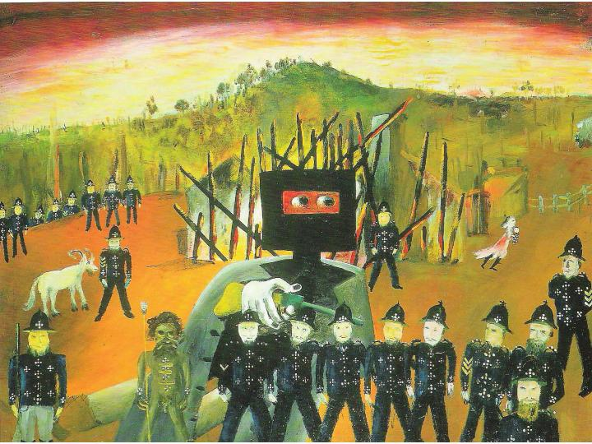
This painting is ‘Glenrowan’ of 1946, and depicts the dramatic shoot-out that ended Kelly’s career as a Bushranger.

I also became interested in the inter-relationships between history, heritage, popular culture and craft practice.
Captain Cook’s ‘annexation’ of New South Wales in 1770, leading to British colonisation in 1788, is celebrated by one section of Australian society, yet indigenous Protest groups regard these dates as the commemoration of…”Years of misery and degradation imposed upon the original native inhabitants by the white invaders of this country.”
(A quote from the Australian Aboriginal League Manifesto statement of 1938)

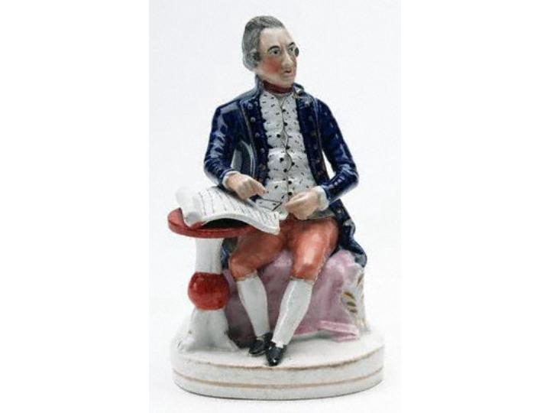

Here Cook is celebrated as British national hero, in the popular form of a Staffordshire pottery figure.

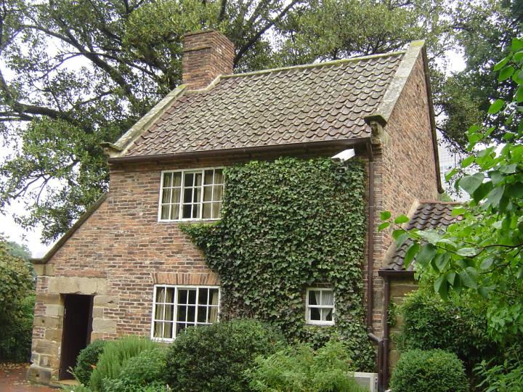
And Cook’s cottage was ‘transported’ brick by brick from Great Ayton in North Yorkshire to Fitzroy Gardens in Melbourne in 1934, to become another iconic national treasure (and arguably the ‘oldest’ building in Australia.)
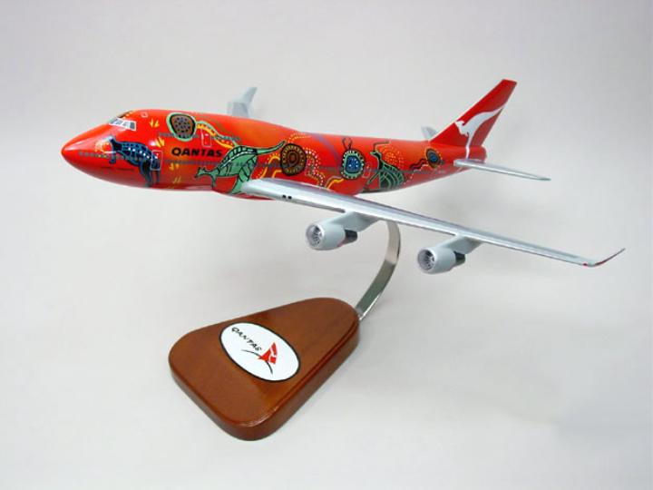

This image perhaps provides the most extreme example of cultural dislocation, appropriation and commercialisation; a model of ‘Wanula Dreaming’, one of three Qantas aircraft, painted in the livery of Aboriginal Australia, and claimed to be ‘the largest flying artworks in the world’. The aircraft were designed by indigenous design house BALARINJI designs, based in Adelaide, in 1994.

4. WORK IN PROGRESS

‘Beyond the Seas’ is a project still in progress. The research residency was completed in April, and the project is now in the ‘working-up’ phase. A number of research strands have emerged in the studio, and are currently being developed through models, maquettes and ‘sampling’.
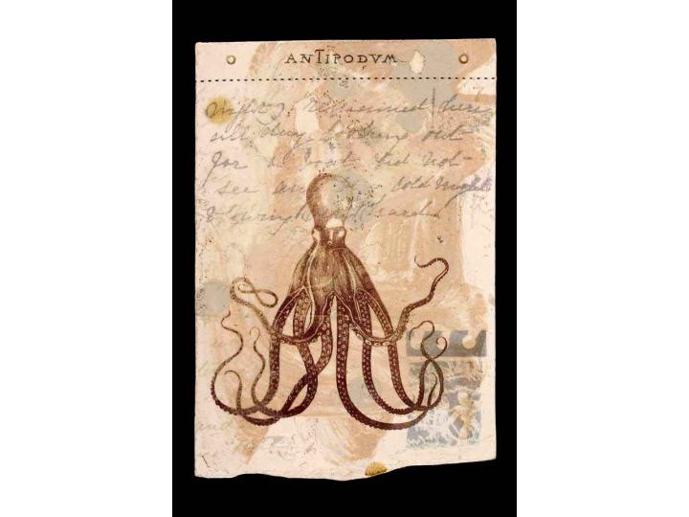
I am constructing an ‘alphabet’ of iconic Australian images; an archive of line-drawings has been turned into screen printed transfers, and sampled onto domestic ware, and onto a series of tile ‘fieldnotes’, which formed a ceramic visual diary of the project

And the making-do attitude of settlers and indigenous Australians has been carried into the studio, transfer printing the alphabet of images onto second hand enamelled tin- plates and vessels.
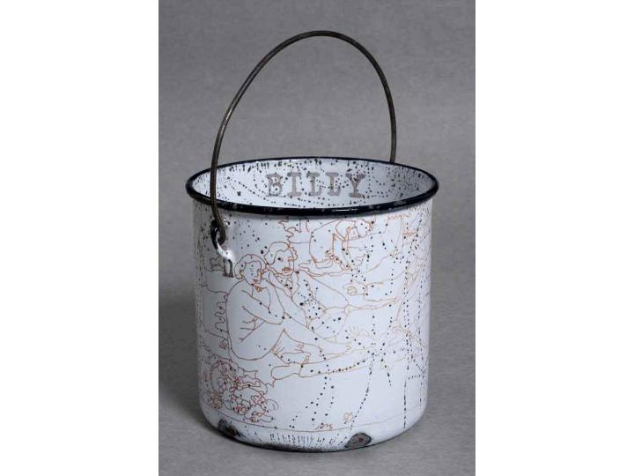

The re-firing of the enamel producing unpredictable but evocative surfaces.

I also printed onto ‘op-shop’ pottery plates, and onto ‘sampled’ plates, which were re-cast from plaster moulds taken from colonial period originals.
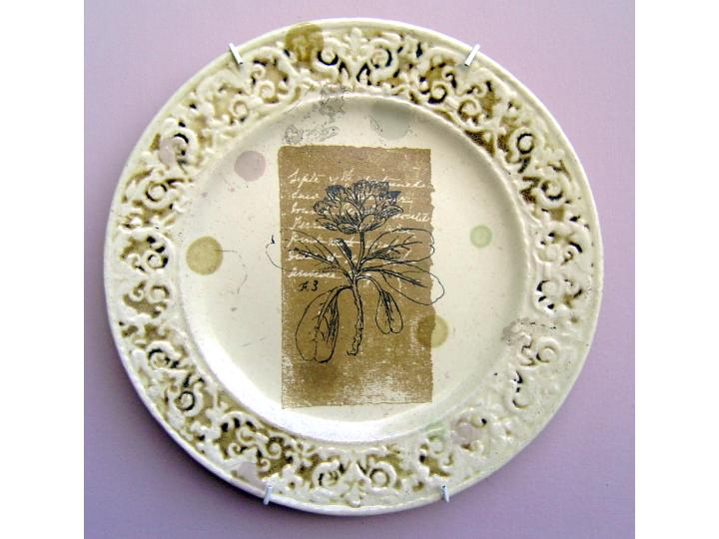

The inter-relationship between heritage, pop-culture and craft practice was explored through the house-image (the crafted house-form is a long term research interest).
A card model of Cook’s birthplace cottage, at Marton-in-Cleveland, and a generic ‘woodcraft’ model barn (collected in Australia but manufactured in China:

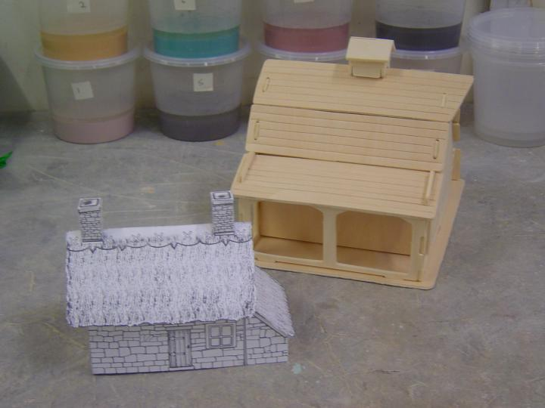
These were developed into a model based on contemporary photographs
of the Kelly family home at 11 mile creek, near Greta, Victoria, combining the constructional logic of the woodcraft barn, with ‘making-do’ materials;
waxed cardboard fruit and vegetable boxes from Adelaide Central Market.
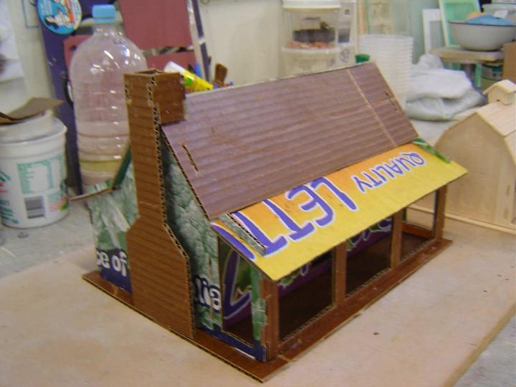

A further range of artefacts, constructed in a number of materials, has explored the theme of masks, cages and outlaws; the silence hood from Melbourne Gaol, re-made and re-interpreted as a metaphor for the Aboriginal experience:
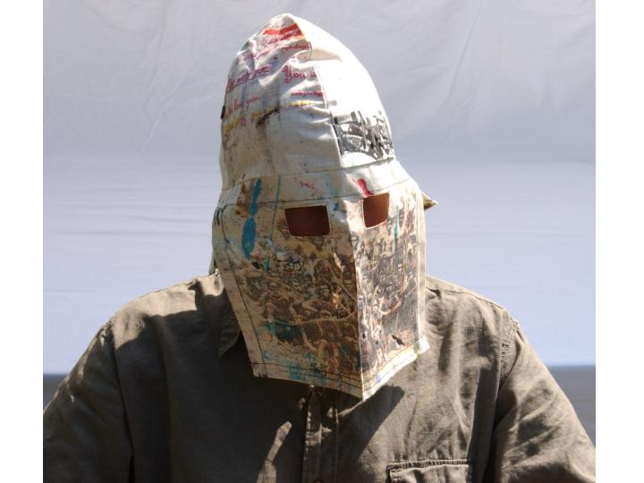

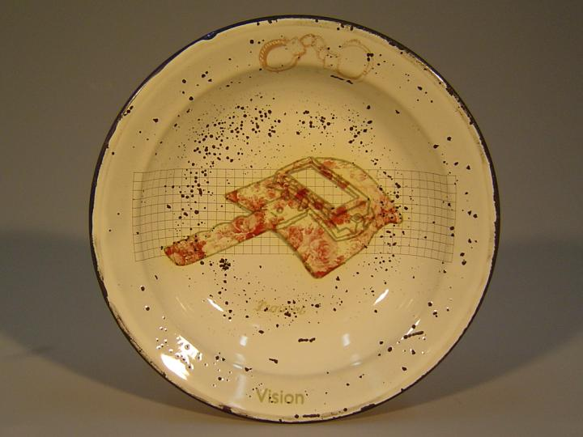
A protective kiln visor, from the studio at the Jam Factory has been incorporated into the ‘Alphabet’ of transfer-printed images.

And the grid-structure of the bird cage echoed in a group of ‘hypothetical’ and ‘impractical’ tool-forms, which combine elements of ‘making-do’ with references to ethical issues and contemporary Australian lifestyle (the ubiquitous ‘barbie’.)
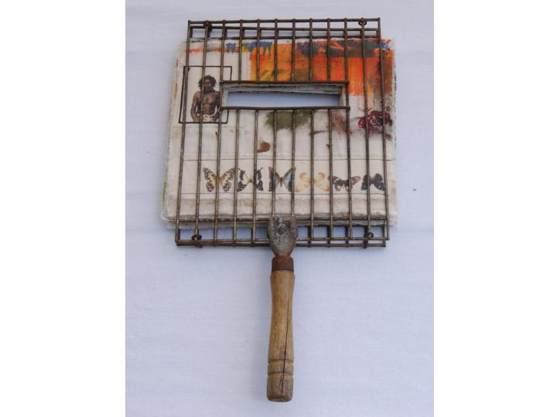

5. RESEARCH PROJECT OUTCOMES.

My intention was to use the opportunity of the research residency to make radical changes in my practice. Some strands of the research have begun to achieve this, while other strands have resulted in more subtle modifications of existing practices, materials and surfaces.

Though not complete, the project has already had several public airings:
A group of the transfer-printed enamel pieces were shown in the exhibition ‘Surface Tension’ at the Jam Factory in March 2006, and a selection of the collaged ‘alphabet’ plates will be exhibited at SOFA Chicago in November 2006.
Two articles by Stephen Bowers, on the ceramic residencies at the Jam Factory, have been published:
‘Home and Away’ (Journal of Australian Ceramics) Vol 45#2006, and
‘Wandering Stars’ (Ceramics: Art and Perception) no.65 2006.

